Create an Audio Transcript with Amazon Transcribe

1. Create an S3 bucket and upload sample audio file.

a. First download sample audio file [transcribe-sample.mp](http://transcribe-sample.mp/)3.

b. Select AWS Console to open and select US West(Oregon) region.

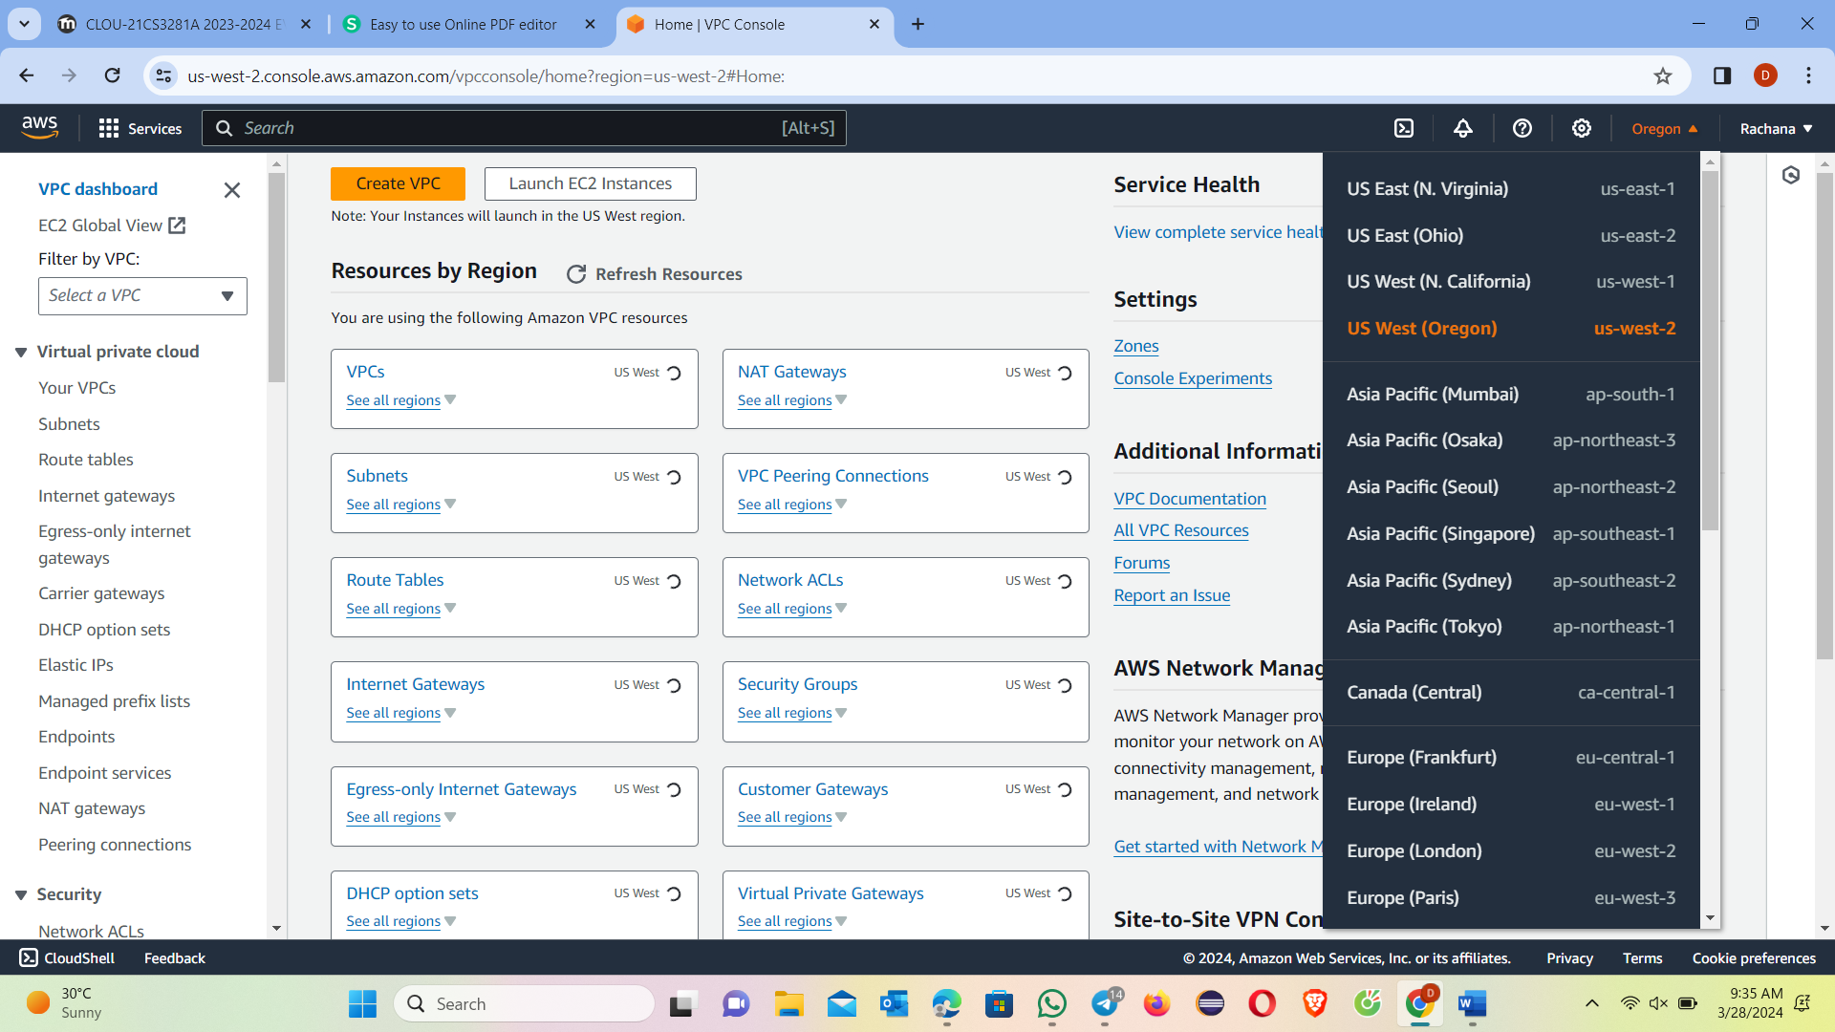

c. Type S3 in search bar and select S3 to open console.

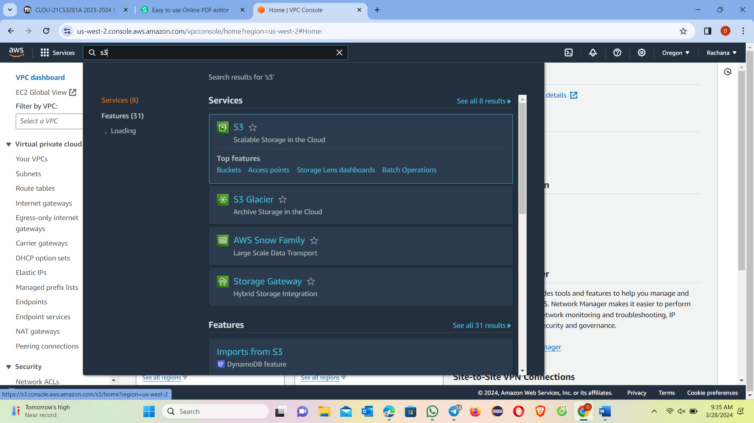

d. In S3 dashboard choose create bucket.

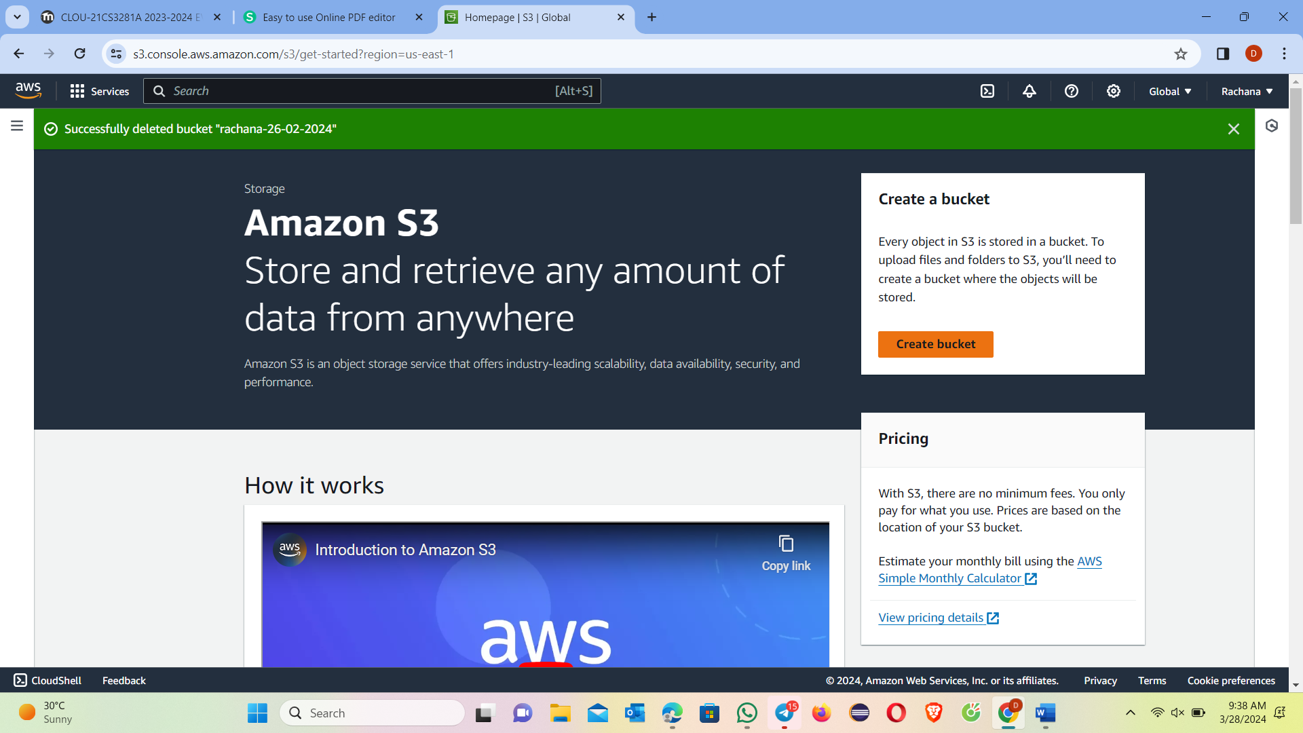

e. Give a unique bucket name.

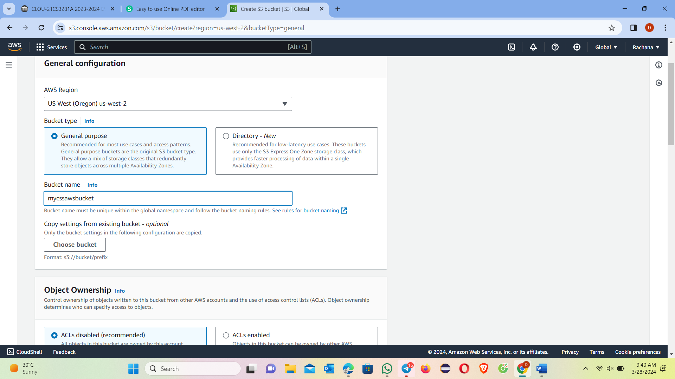

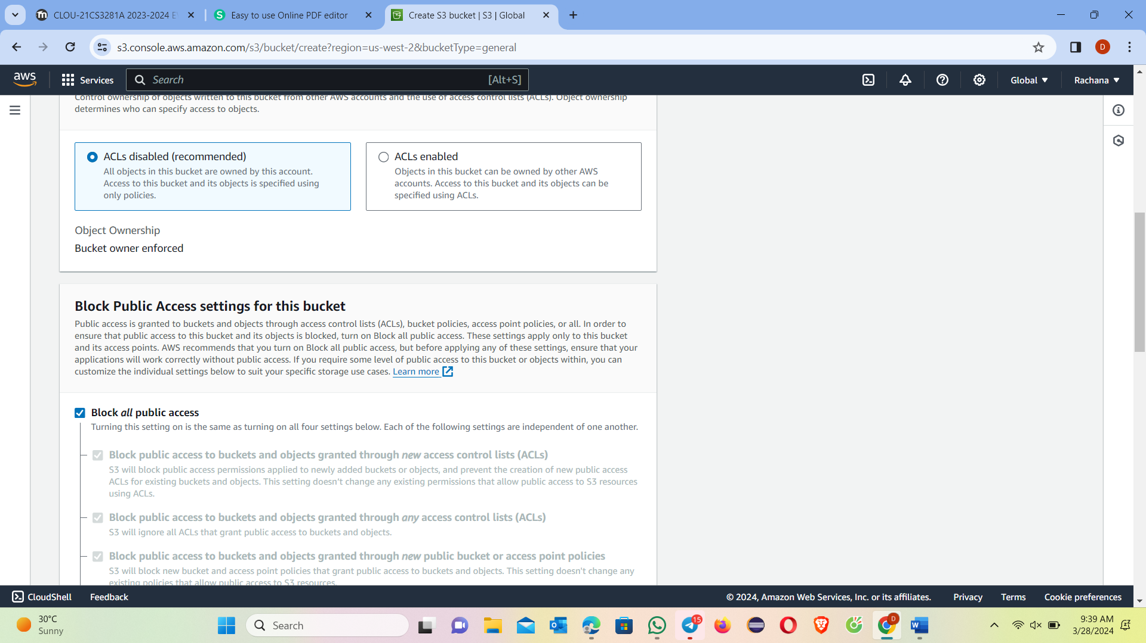

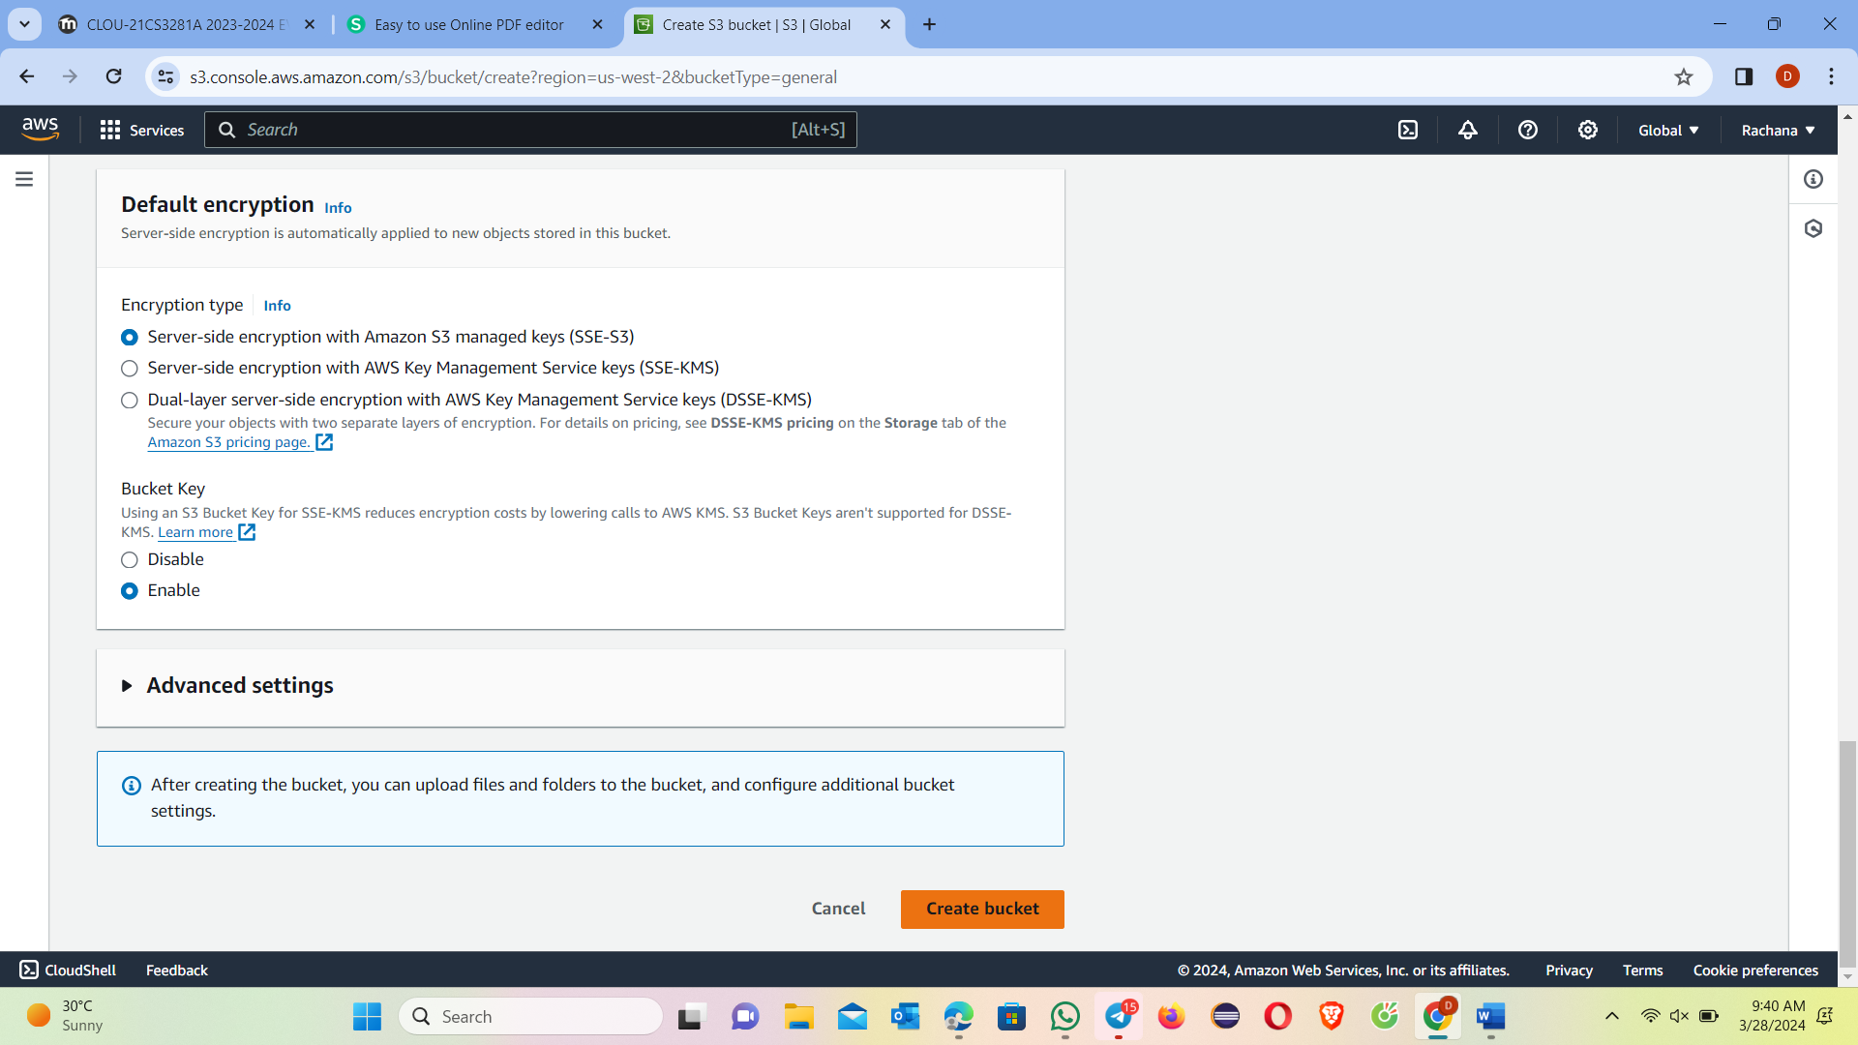

f. You will see your new bucket in S3 console. Click on your bucket's name to navigate to the bucket.

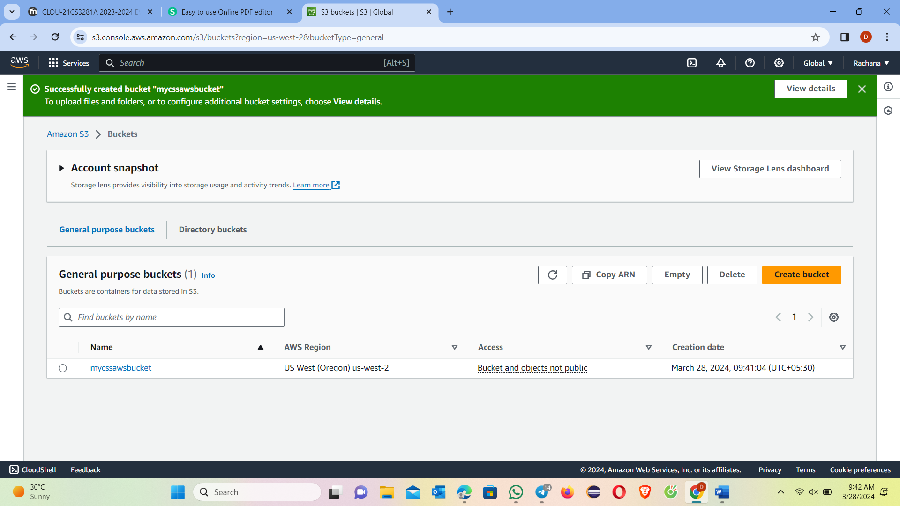

g. Select upload in your bucket's home page.

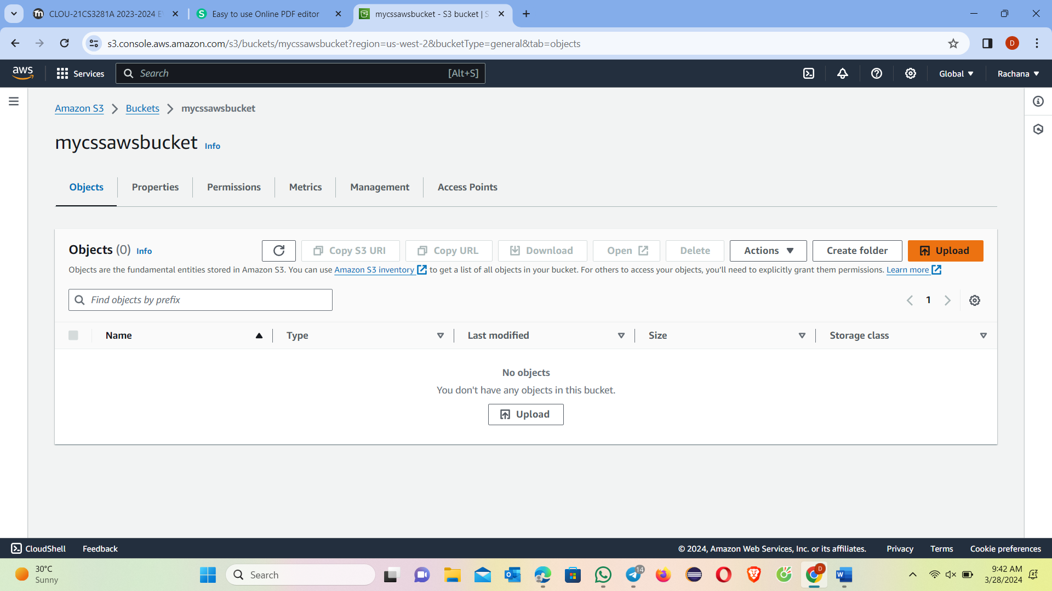

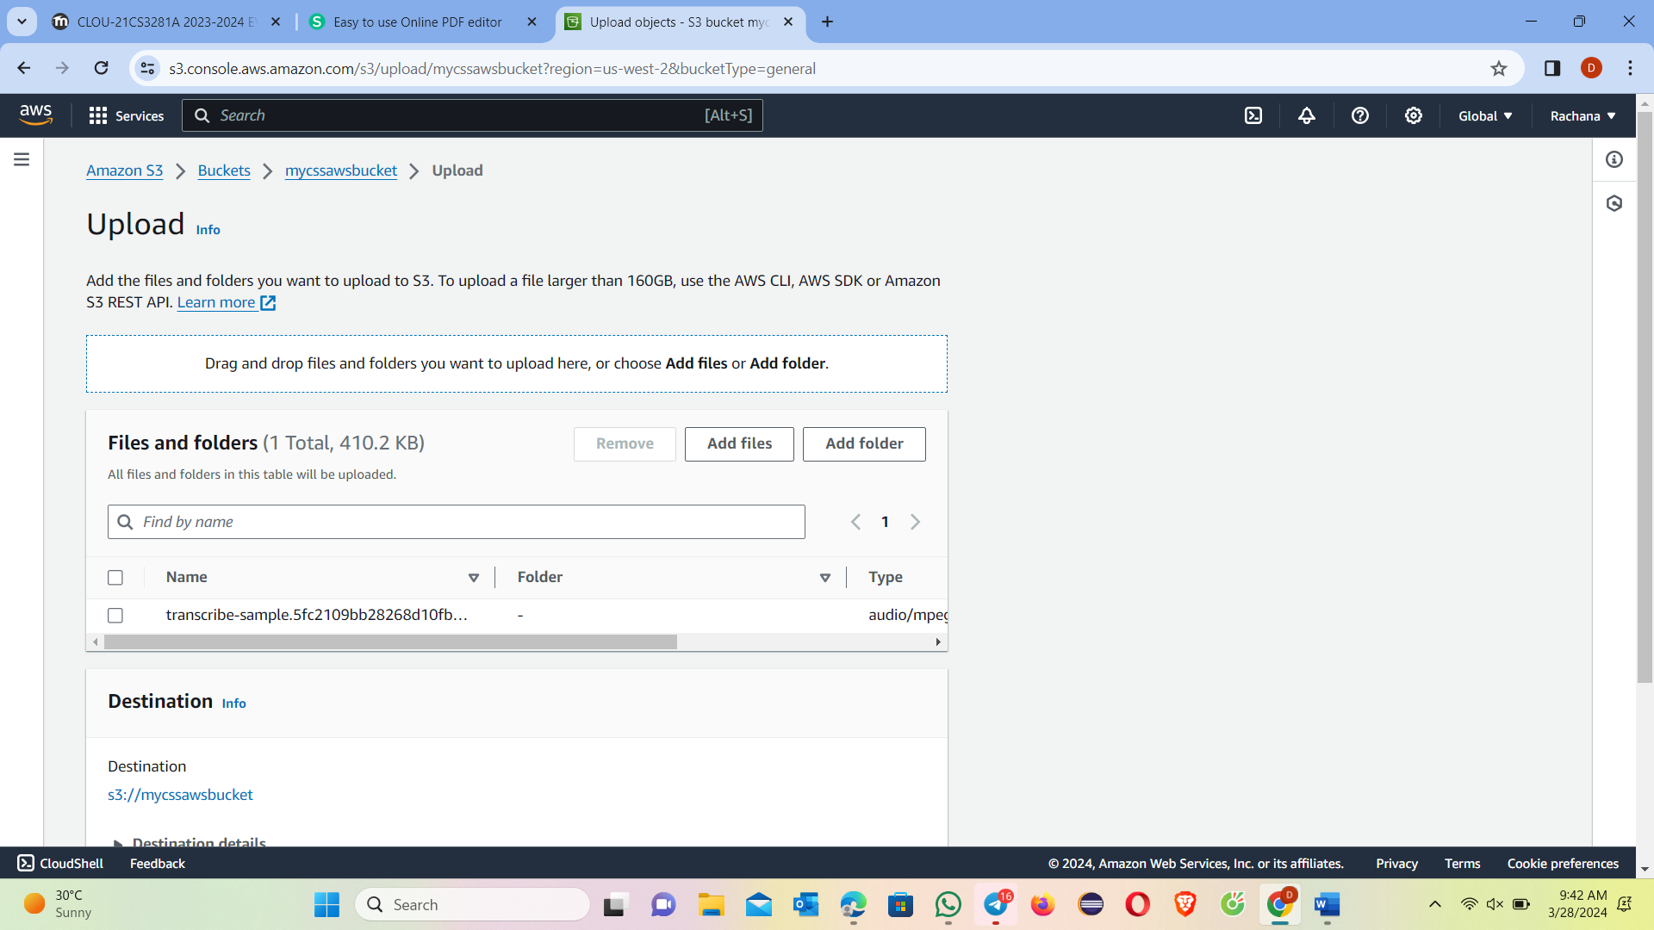

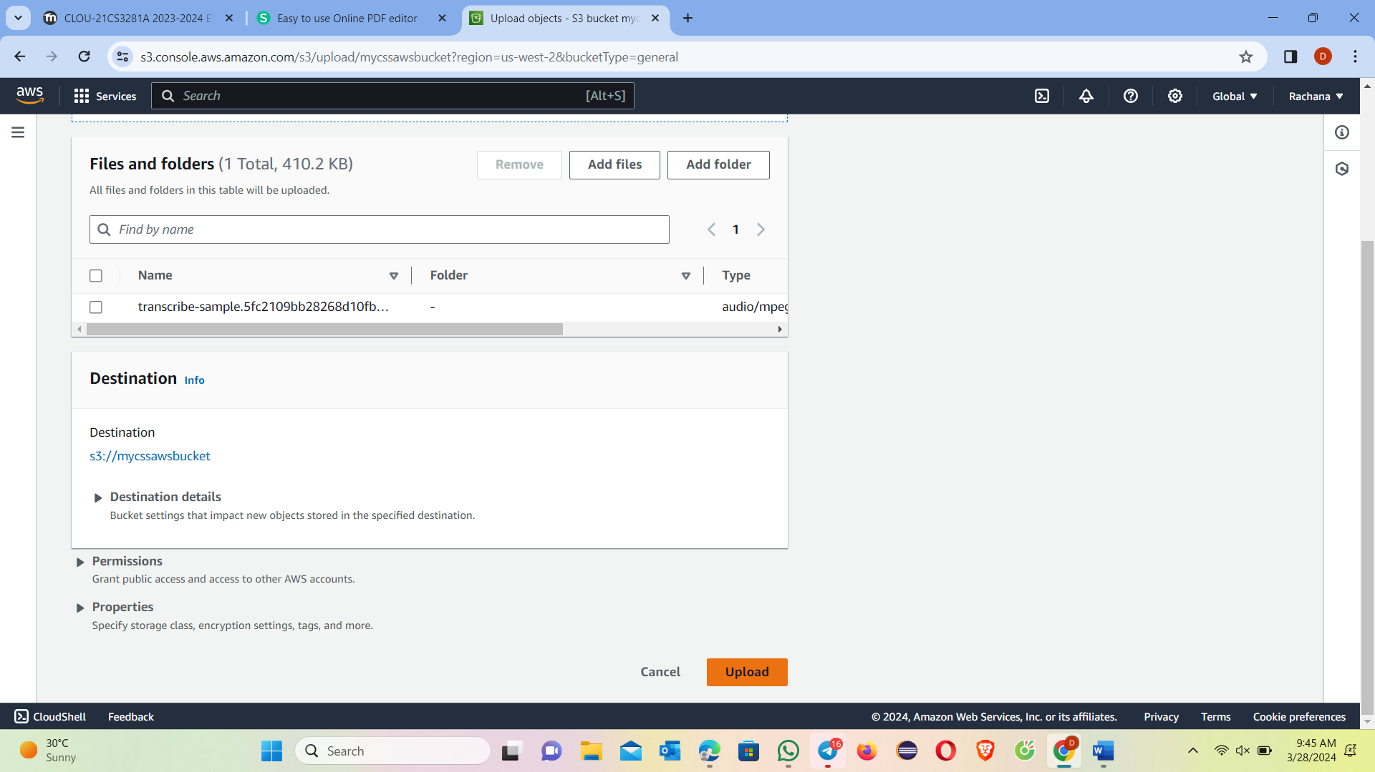

i. On successful upload select the mp3 file in your bucket. A file detail page will be displayed for mp3 file. Copy S3 URL link to the file and save it.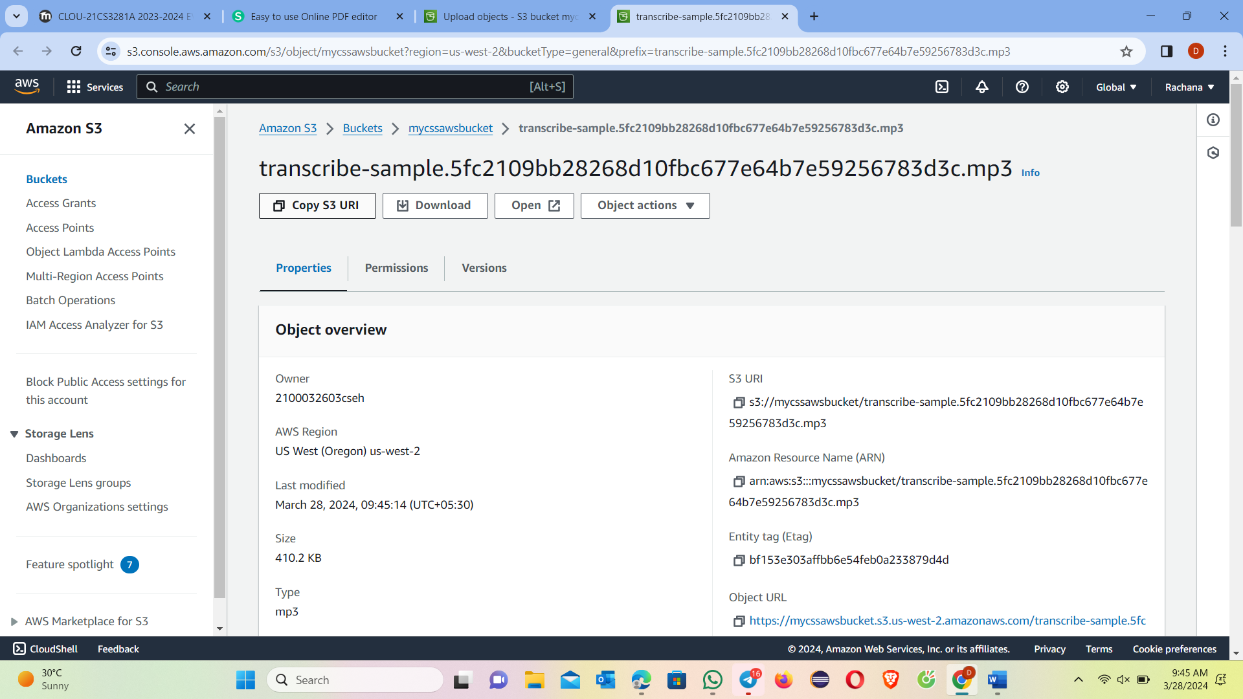

2. Create transcription job:

a. From services type transcribe in search bar and select Amazon Transcribe to open console.

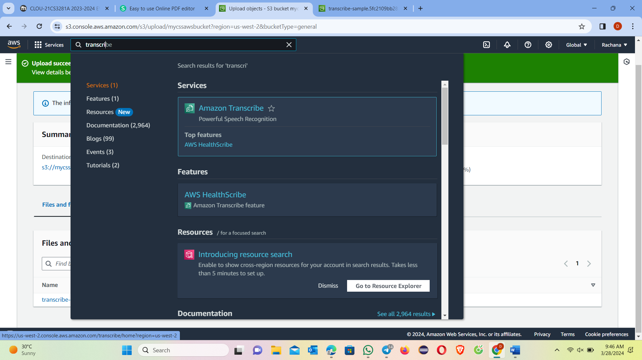

b. On Amazon Transcribe console page open navigation pane and click transcription jobs and create.

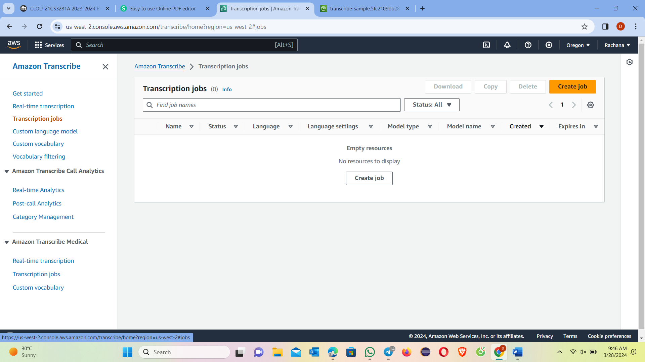

c. On create transcription job page in name field type sample-transcription-job.

Leave the default language as English.

Leave the default model type as General model.

In input file location on S3 field paste link to sample file in your S3 bucket.

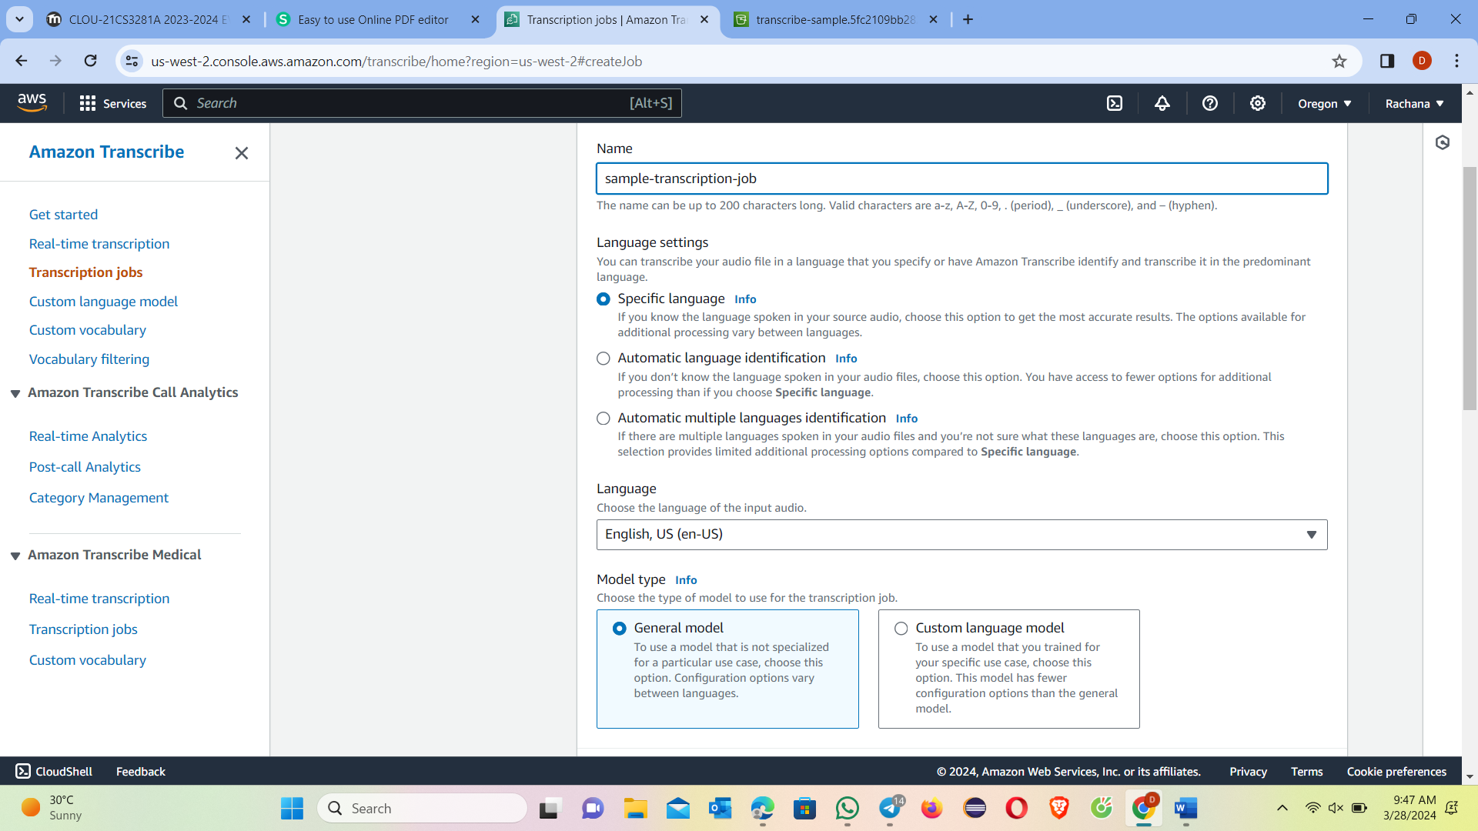

d. Leave default Output data location type as Service-managed S3 bucket.

Select next.

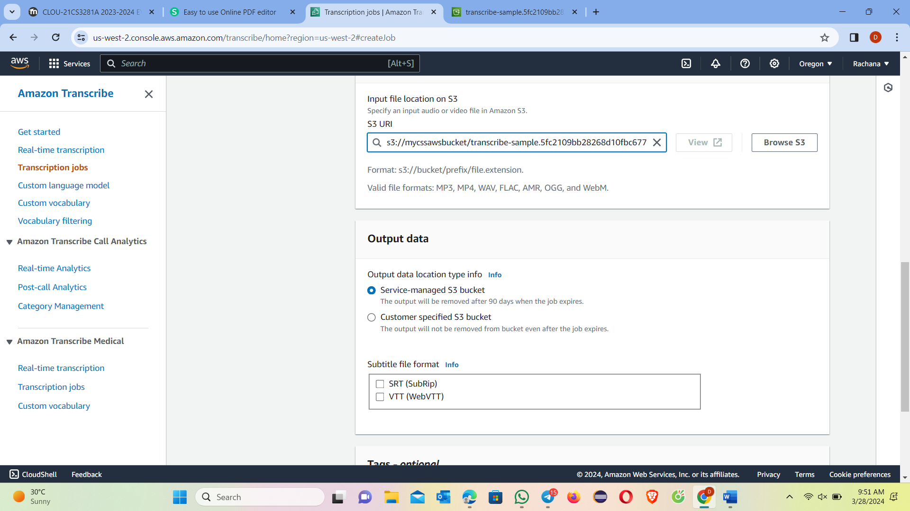

e. Leave the default choices and select create job.

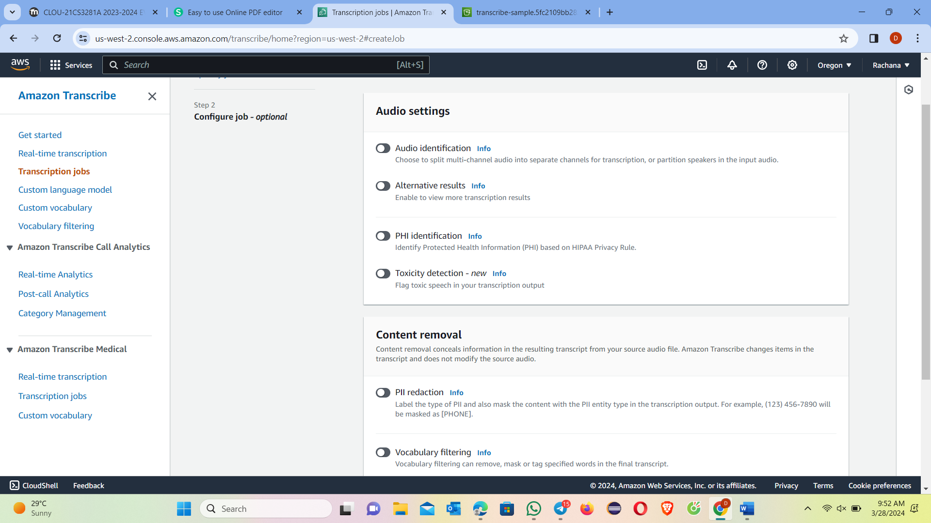

3. Review transcription results:

a. After you click Create job button you will be taken to Transcription jobs screen. It will show completed status.

When the status is complete click on sample-transcription-job link in name column to view transcription results.

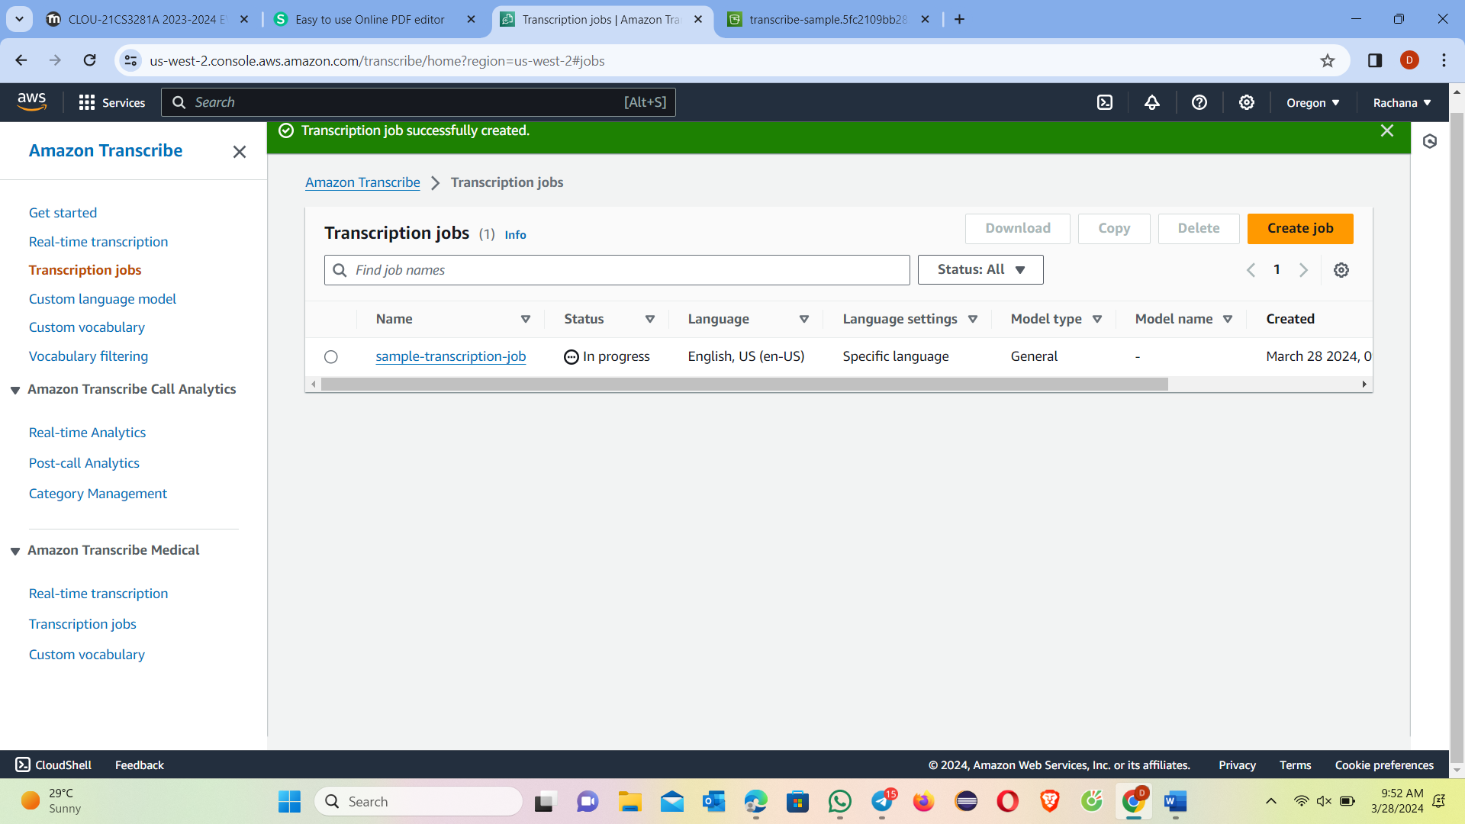

b. Next you will see the sample-transcription-job details. Scroll down to the Transcription panel to view the transcription job output.

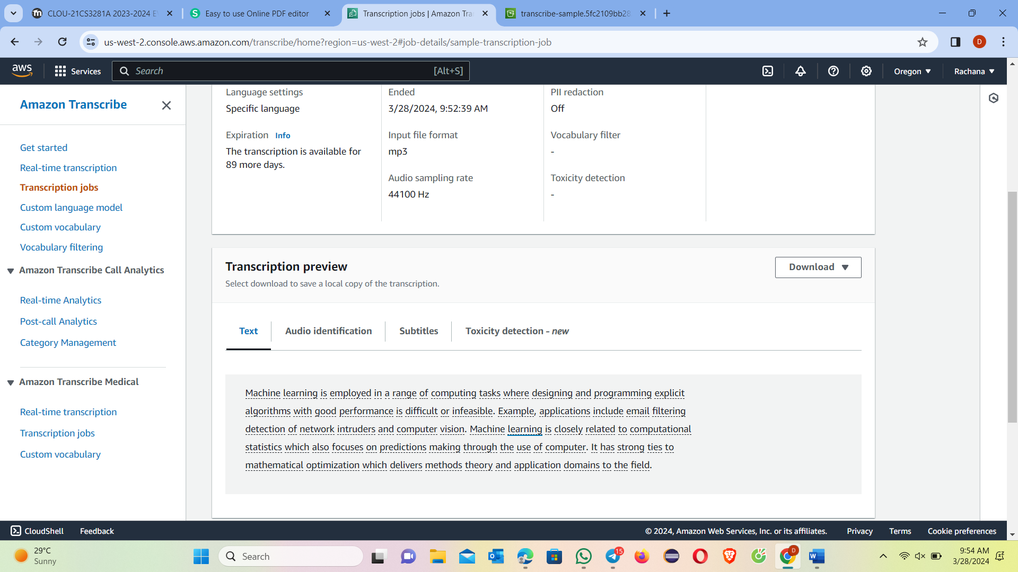

We completed the conversion of audio into text.